Types of Frames
# Source: AI Source: Provided by: [Data Path: Persons Table -> ID Column: 1, Name_En Column: Motasem Essam] -> From: [ChatGPT] on [1/16/2026]
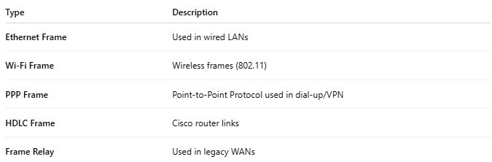
Type | Description
Ethernet Frame | Used in wired LANs
Wi-Fi Frame | Wireless frames (802.11)
PPP Frame | Point-to-Point Protocol used in dial-up/VPN
HDLC Frame | Cisco router links
Frame Relay | Used in legacy WANs

